**Lab 3 – Selection Structures**

Open PyCharm and Create a Project called Lab3. In Lab3 create a Python package task1.

**Ex1**

Write a Python script, to read a number. If the number is positive, print “it is a positive number!’. If the number is negative or zero, print appropriate messages.

**Ex2**

Write a Python script to calculate yearend Bonus payments. Bonus calculated as follows:

Job category 1 bonus = salary * 1.02

Job category 2 bonus = salary * 1.05

Job category 3 bonus = salary * 1.1

Your script must ask the user’s job category and salary. Then display the bonus. Format your output.

**Ex3**

Implement and run Class Exercise 3, in lecture slides. Test your code. Once it is producing desired outcomes, update your code as follows.

1. If the total ticket cost exceeds $100, add 10% discount to the total price.
2. Format all your outputs.

**Additional Exercises**

**Ex4**

**Pet Happiness** is an online dog food store. Write a program to calculate dog food purchases from **Pet Happiness**. For each order made there is a standard delivery fee of $15. However, orders over $100 receives free delivery.

Dogfood bags come in 3 pack sizes and cost as follows:

20kg (Large) - $100.00

15kg (Medium) - $70.00

5kg (Small) - $40.00

In each bag size there are 2 varieties for adult dogs and puppy dogs. All puppy dog food bags cost $5 less than the above given prices. Inputs and outputs from the program for 3 different inputs are given below for comparison.

Output 1

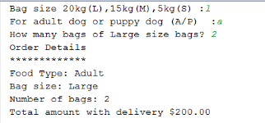

Output 2

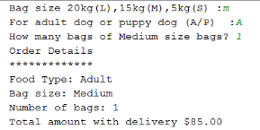

Output 3

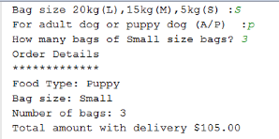

NOTE: Bag size and food type can be provided using lower or uppercase letters.

Third question displays the bag size, which was entered as the input of the previous question. Total is formatted.

**Ex5**

At a florist flowers are sold as follows:

5 stems pre-arranged bunch for $10

10 stems pre-arranged bunch $15

Any individual flower cost $2 each

Customers can purchase any combination of the above. Write a Python program to calculate flower sales. If the total goes above $50, they can chose 2 additional flowers free. Sample output look as follows.

Output 1

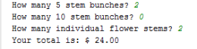

Output 2

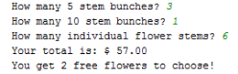

**Ex6**

Write a python program to compare two integers and provide an output.

Your program should compare the two integers and print if they are;

Equal (==)

Greater than (>)

Less than (<)

Greater than or equal (>=)

Less than or equal (<=)

Not equal (!=)

Your programming output should look as follows.

Output 1

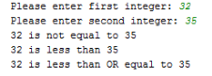

Output 2

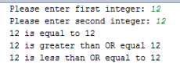

**Ex7**

Modify additional exercise (Book Store - purchase price calculation) program in Lab 2 to ask the “number of days renting” only if they are renting books. Otherwise, the program should just calculate the price of purchased books.